BANK LOAN APPROVAL PREDICTION
A Machine Learning Capstone Project Documentation

Submitted by
Rupjit Das
Bachelor of Computer Applications (BCA) — 3rd Year
Project Type: Machine Learning & AI
Tools: Python, Pandas, Scikit-learn, Seaborn, Matplotlib

Table of Contents
Abstract 4
1. Introduction 4
2. Problem Statement 4
3. Business Objective 5
4. Dataset Description 5
5. Technology Stack 6
6. Project Workflow 6
7. Data Cleaning & Missing Value Handling 7
8. Exploratory Data Analysis (EDA) 7
8.1 Target Variable Distribution 7
8.2 Categorical Features vs Loan Status 8
8.3 Numerical Feature Distributions 9
9. Feature Engineering 10
10. Encoding Techniques 10
10.1 Label Encoding (Binary Columns) 10
10.2 One-Hot Encoding (Multi-category Columns) 10
11. Train-Test Split 10
12. Feature Scaling 11
13. Model Building 11
13.1 Logistic Regression 11
13.2 Random Forest 11
13.3 Decision Tree 11
14. Evaluation Metrics 11
14.1 Logistic Regression — Results 12
14.2 Random Forest — Results 12
Feature Importance (Random Forest) 13
14.3 Decision Tree — Results 14
15. Model Comparison and Best Model Selection 15
16. Model Saving and Loading using Joblib 15
17. Results 16
18. Challenges Faced 16
19. Business Impact 16
20. Future Scope 17
21. Conclusion 17
22. References 18

Abstract
Access to timely and fair credit is central to a bank's relationship with its customers, yet manually reviewing every loan application is slow and inconsistent. This project builds a machine learning system that predicts whether a bank loan application will be approved or rejected, using a dataset of 614 historical loan applications containing applicant demographics, income details, loan attributes, and credit history.
The work follows a complete, reproducible ML pipeline: loading and inspecting the raw data, identifying and treating missing values, performing exploratory data analysis (EDA) to understand patterns behind loan approval, encoding categorical variables, splitting the data into training and testing sets, scaling numerical features, and training three classification algorithms — Logistic Regression, Decision Tree, and Random Forest. Each model was evaluated using Accuracy, Precision, Recall, F1-Score, and the Confusion Matrix.
Logistic Regression and Random Forest both achieved the highest test accuracy of 78.86%, with Logistic Regression showing a marginally higher recall (98.75%) for approved loans. Credit History emerged as the single most influential feature in the Random Forest importance analysis, followed by Applicant Income and Loan Amount. The trained Logistic Regression model was serialized using Joblib for potential reuse. This documentation captures every step exactly as implemented in the accompanying Jupyter Notebook, along with business interpretation of the results.

1. Introduction
Loan approval is one of the most frequent and consequential decisions a bank makes. Every application must be assessed against a mix of financial and personal factors — income, existing obligations, credit history, and more — to judge the applicant's ability to repay. Traditionally, this assessment is performed manually by loan officers using internal policy rules, which can be time-consuming and subject to inconsistency between reviewers.
This project uses machine learning to learn approval patterns directly from historical loan data. By training classification models on past applications where the outcome (approved or rejected) is already known, the system learns to predict the outcome for new, unseen applications. The project covers the complete data science lifecycle — from raw data to a comparison of trained models — and is documented step by step in this report, closely following the implementation in the project's Jupyter Notebook (week4.ipynb).

2. Problem Statement
Given a set of applicant attributes — such as gender, marital status, number of dependents, education, employment type, income, co-applicant income, loan amount, loan term, credit history, and property area — the goal is to build a classification model that predicts the target variable Loan_Status, i.e., whether a loan application will be Approved (Y) or Rejected (N).
This is framed as a binary classification problem. The challenge lies in the presence of missing values across several columns, a mix of categorical and numerical features that must be encoded and scaled appropriately, and a target class that is not perfectly balanced (more approvals than rejections in the historical data).

3. Business Objective
From a business standpoint, an automated loan approval prediction model can support the bank in several ways:
- Faster decision-making: Reduce the manual effort and turnaround time needed to evaluate each application.
- Consistency: Apply the same learned criteria uniformly across all applicants, reducing reviewer-to-reviewer variation.
- Risk indication: Flag applications with a high likelihood of default/rejection so loan officers can prioritize careful manual review.
- Customer experience: Provide quicker feedback to applicants on the likely outcome of their application.
The intent of this capstone project is to demonstrate this predictive capability end-to-end using a real-world style dataset, not to replace a bank's formal credit policy or underwriting process.

4. Dataset Description
The dataset (bank_loan.csv) was loaded using pandas and contains 614 rows and 13 columns, each row representing one historical loan application.
Column | Description | Type
Loan_ID | Unique application identifier | Categorical (Identifier)
Gender | Applicant gender (Male / Female) | Categorical
Married | Marital status (Yes / No) | Categorical
Dependents | Number of dependents (0, 1, 2, 3+) | Categorical
Education | Graduate / Not Graduate | Categorical
Self_Employed | Self-employed status (Yes / No) | Categorical
ApplicantIncome | Applicant's monthly income | Numerical
CoapplicantIncome | Co-applicant's monthly income | Numerical
LoanAmount | Loan amount requested (in thousands) | Numerical
Loan_Amount_Term | Loan repayment term (in months) | Numerical
Credit_History | Whether credit history meets guidelines (1 / 0) | Categorical (numeric-coded)
Property_Area | Urban / Semiurban / Rural | Categorical
Loan_Status | Target variable — loan approved (Y) or not (N) | Categorical (Target)

Target class balance: Of the 614 applications, 422 loans were approved (Y) and 192 were rejected (N) — a roughly 69% / 31% split, indicating a moderately imbalanced target.

5. Technology Stack
The following libraries and tools, as imported in the notebook, were used to build this project:
Library / Tool | Purpose in this Project
Python | Core programming language for the entire pipeline
Pandas | Loading the CSV file, data inspection, cleaning, and feature encoding (get_dummies)
NumPy | Underlying numerical operations used by pandas / scikit-learn
Seaborn | Statistical visualizations — count plots, histograms, heatmaps, bar plots
Matplotlib | Plot rendering and figure layout (subplots, titles, labels)
Scikit-learn (sklearn) | LabelEncoder, train_test_split, StandardScaler, LogisticRegression, DecisionTreeClassifier, RandomForestClassifier, and evaluation metrics
Jupyter Notebook | Interactive development and documentation environment
Joblib | Serializing (saving) the trained Logistic Regression model

6. Project Workflow
The project follows the pipeline below, in the same order implemented in the notebook:
- 1. Import libraries (pandas, numpy, seaborn, matplotlib, scikit-learn modules, xgboost, joblib).
- 2. Load the dataset (bank_loan.csv) and inspect it with .head() and .describe().
- 3. Check for duplicate records using .duplicated().
- 4. Check for missing values using .isnull().sum().
- 5. Handle missing values — mode imputation for categorical columns, median/mode imputation for numerical columns.
- 6. Re-verify that no missing values remain.
- 7. Perform Exploratory Data Analysis (target distribution, categorical breakdowns, numerical distributions).
- 8. Encode categorical variables — Label Encoding for binary columns, One-Hot Encoding for multi-category columns.
- 9. Drop the non-predictive Loan_ID column.
- 10. Separate features (X) and target (y).
- 11. Split the data into training and testing sets (80% / 20%).
- 12. Scale numerical/encoded features using StandardScaler.
- 13. Train three classification models: Logistic Regression, Random Forest, Decision Tree.
- 14. Evaluate each model using Accuracy, Precision, Recall, F1-Score, and Confusion Matrix.
- 15. Compare all models in a single results table and identify the best performer.
- 16. Save the final trained model using Joblib.

7. Data Cleaning & Missing Value Handling
The notebook first checked for duplicate rows using df.duplicated() — no duplicate records were found in the dataset. The missing value check using df.isnull().sum() showed the following gaps:
Column | Missing Values (before) | Imputation Method Used
Gender | 13 | Mode imputation
Married | 3 | Mode imputation
Dependents | 15 | Mode imputation
Self_Employed | 32 | Mode imputation
LoanAmount | 22 | Median imputation
Loan_Amount_Term | 14 | Mode imputation
Credit_History | 50 | Mode imputation

Implementation detail: categorical columns (Gender, Married, Dependents, Self_Employed) were filled together in a loop using each column's most frequent value (mode). LoanAmount, being numerical and right-skewed, was filled with its median to avoid the influence of outliers. Loan_Amount_Term and Credit_History — both numeric but effectively categorical/discrete in nature — were filled using their mode.
categorical_cols = ["Gender","Married","Dependents","Self_Employed"]
for col in categorical_cols:
df[col] = df[col].fillna(df[col].mode()[0])
df["LoanAmount"] = df["LoanAmount"].fillna(df["LoanAmount"].median())
df["Loan_Amount_Term"] = df["Loan_Amount_Term"].fillna(df["Loan_Amount_Term"].mode()[0])
df["Credit_History"] = df["Credit_History"].fillna(df["Credit_History"].mode()[0])
After these steps, df.isnull().sum() confirmed zero missing values across all 13 columns.

8. Exploratory Data Analysis (EDA)

8.1 Target Variable Distribution
A count plot of Loan_Status shows the split between approved and rejected applications.
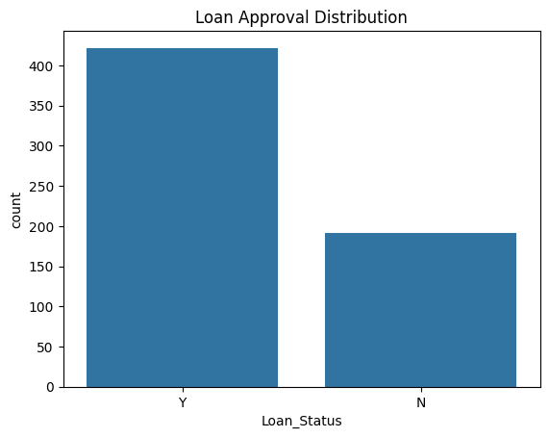
Figure 1: Distribution of Loan_Status (Approved vs Rejected)
Observation: 422 applications were approved (Y) and 192 were rejected (N).
Business Insight: The historical approval rate is close to 69%, meaning the dataset is moderately imbalanced toward approvals. Models trained on this data may naturally lean toward predicting approval unless this imbalance is accounted for, which is important context when interpreting recall and precision for the rejected class.

8.2 Categorical Features vs Loan Status
Count plots of Gender, Married, Dependents, Education, Self_Employed, and Property_Area were plotted against Loan_Status to see how approval varies across categories.
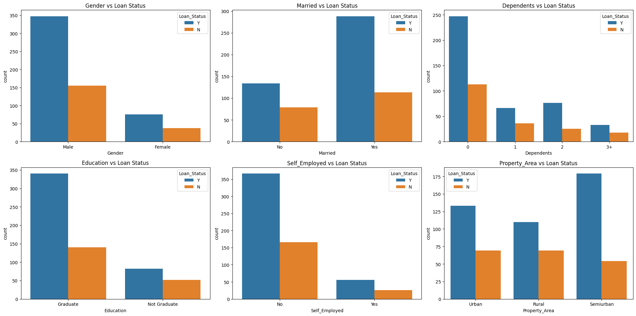
Figure 2: Categorical Features vs Loan Status
Observations from value counts and the plots:
- Gender — 502 Male vs 112 Female applicants. Approvals dominate in both groups, but the sample is heavily skewed toward male applicants, so gender alone shows limited separating power.
- Married — 401 Yes vs 213 No. Married applicants form the majority and show a higher share of approvals.
- Dependents — 360 applicants have 0 dependents, followed by 102 (1), 101 (2), and 51 (3+). All groups contain both approvals and rejections.
- Education — 480 Graduate vs 134 Not Graduate. Graduates are the majority class and also show more approvals in absolute count.
- Self_Employed — 532 No vs 82 Yes. Both groups are approval-dominant; employment type does not visually stand out as a strong differentiator.
- Property_Area — Semiurban (233), Urban (202), Rural (179) are fairly balanced; the plot indicates Semiurban applicants have a comparatively higher share of approvals.
Business Insight: None of the categorical demographic attributes (gender, marital status, dependents, education, employment type) show a dramatic standalone split between approval and rejection — this suggests the bank's approval decision likely depends more heavily on financial capacity and credit-worthiness attributes than on demographic profile, which is a reassuring, fairness-oriented pattern.

8.3 Numerical Feature Distributions
Histograms with KDE overlays were plotted for ApplicantIncome, CoapplicantIncome, LoanAmount, and Loan_Amount_Term.
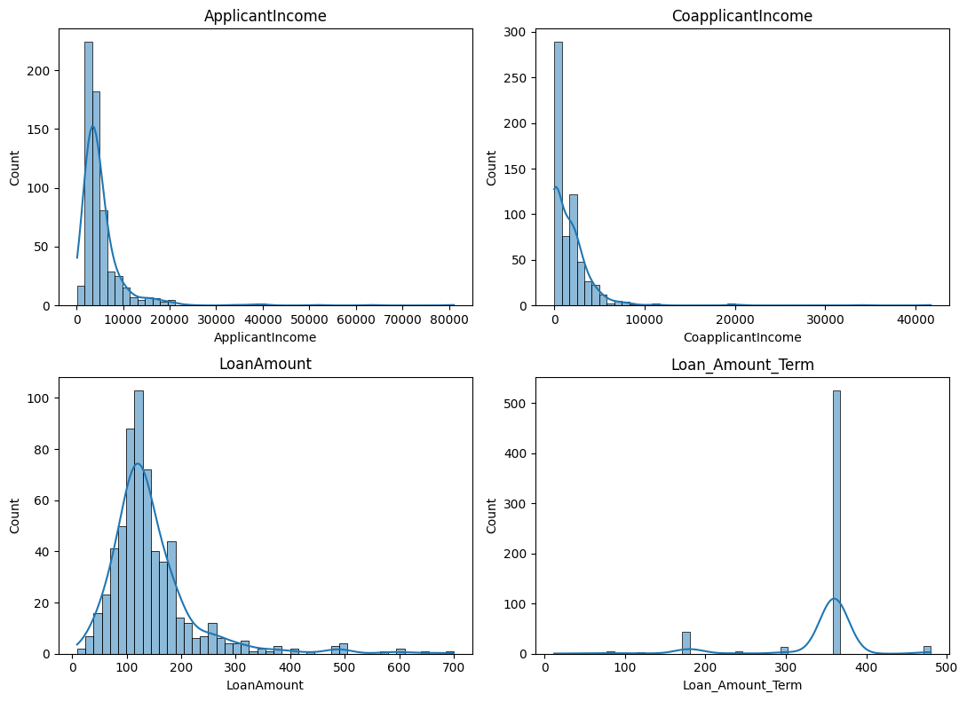
Figure 3: Distribution of Numerical Features
Observation: ApplicantIncome, CoapplicantIncome, and LoanAmount are all right-skewed, with a long tail of high-income/high-loan applicants (matching the .describe() output, e.g. ApplicantIncome ranges from 150 up to 81,000 with a mean of ~5,403). Loan_Amount_Term is concentrated heavily around 360 months, with a smaller cluster near 180 months.
Business Insight: The skew and outliers in income and loan amount justify using feature scaling (StandardScaler) before training distance/gradient-sensitive models such as Logistic Regression, so that a small number of very high-income applicants do not disproportionately dominate the learned coefficients.

9. Feature Engineering
The notebook's feature preparation was limited to encoding existing columns into a model-ready numeric format; no new derived features (such as income ratios or binned categories) were engineered in this version of the notebook. The only structural change applied was dropping the Loan_ID column, since it is a unique identifier with no predictive value:
df.drop(['Loan_ID'], axis=1, inplace=True)
Suggestion (not implemented in the current notebook): future iterations could engineer features such as Total_Income (ApplicantIncome + CoapplicantIncome) or a Loan-to-Income ratio, which are commonly useful signals in credit risk modelling.

10. Encoding Techniques

10.1 Label Encoding (Binary Columns)
The columns Gender, Married, Education, Self_Employed, and the target Loan_Status were converted to numeric form using scikit-learn's LabelEncoder, since each has only two categories:
binary_cols = ["Gender","Married","Education","Self_Employed","Loan_Status"]
le = LabelEncoder()
for col in binary_cols:
df[col] = le.fit_transform(df[col])

10.2 One-Hot Encoding (Multi-category Columns)
Dependents (0, 1, 2, 3+) and Property_Area (Rural, Semiurban, Urban) have more than two categories, so they were one-hot encoded using pandas.get_dummies with drop_first=True to avoid redundant (dummy-variable-trap) columns:
df = pd.get_dummies(df, columns=["Dependents", "Property_Area"], drop_first=True)
This produced new binary columns: Dependents_1, Dependents_2, Dependents_3+, Property_Area_Semiurban, and Property_Area_Urban (with Dependents=0 and Property_Area=Rural as the implicit reference categories).

11. Train-Test Split
After encoding, the dataset was split into a feature matrix X (all columns except Loan_Status) and target vector y (Loan_Status). The data was then split into training and testing subsets using an 80/20 ratio with a fixed random_state for reproducibility:
X = df.drop("Loan_Status", axis=1)
y = df["Loan_Status"]
X_train, X_test, y_train, y_test = train_test_split(
X, y, test_size=0.2, random_state=42
)
This resulted in 491 training records and 123 testing records.

12. Feature Scaling
StandardScaler was applied to standardize the feature set so that all features contribute proportionally during model training, particularly important for Logistic Regression:
scaler = StandardScaler()
X_train = scaler.fit_transform(X_train)
X_test = scaler.transform(X_test)
The scaler was fit only on the training data and then used to transform the test data, which avoids data leakage from the test set into the training process.

13. Model Building

13.1 Logistic Regression
A baseline Logistic Regression classifier was trained with default hyperparameters (other than a fixed random_state):
lr_model = LogisticRegression(random_state=42)
lr_model.fit(X_train, y_train)

13.2 Random Forest
A Random Forest ensemble of 100 decision trees was trained:
rf_model = RandomForestClassifier(
n_estimators=100,
random_state=42
)
rf_model.fit(X_train, y_train)

13.3 Decision Tree
A single Decision Tree was trained with its maximum depth restricted to 5, to reduce overfitting:
dt_model = DecisionTreeClassifier(
random_state=42,
max_depth=5
)
dt_model.fit(X_train, y_train)

14. Evaluation Metrics
Each trained model was evaluated on the held-out test set (123 records) using the following metrics:
Metric | What it Measures | Business Meaning
Accuracy | Proportion of total predictions that were correct | Overall correctness of the model across all applications
Precision | Of all applications predicted as Approved, how many were actually approved | How trustworthy a positive (approved) prediction is — low precision means more false approvals
Recall | Of all applications that were actually approved, how many did the model correctly identify | How well the model avoids missing genuinely eligible applicants (false rejections)
F1-Score | Harmonic mean of Precision and Recall | A single balanced score when both false approvals and false rejections carry a cost
Confusion Matrix | A 2x2 breakdown of True Positives, True Negatives, False Positives, and False Negatives | Shows exactly what kinds of mistakes the model makes, beyond a single summary number

14.1 Logistic Regression — Results
Metric | Score
Accuracy | 0.7886 (78.86%)
Precision | 0.7596
Recall | 0.9875
F1-Score | 0.8587

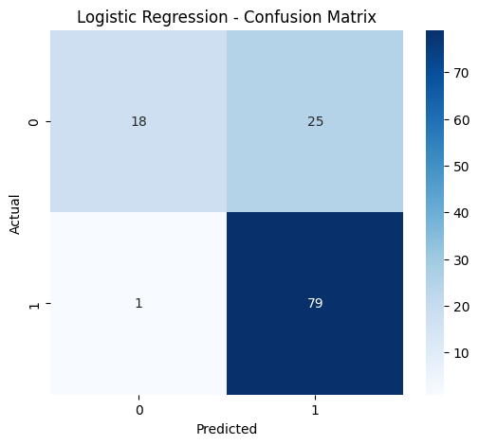
Figure 4: Confusion Matrix — Logistic Regression
Interpretation: The model correctly identifies 98.75% of applicants who were genuinely approved (very high recall for the approved class), but this comes at the cost of lower precision — it also misclassifies a notable number of applicants that should have been rejected as approved, as seen from the confusion matrix.

14.2 Random Forest — Results
Metric | Score
Accuracy | 0.7886 (78.86%)
Precision | 0.7647
Recall | 0.9750
F1-Score | 0.8571

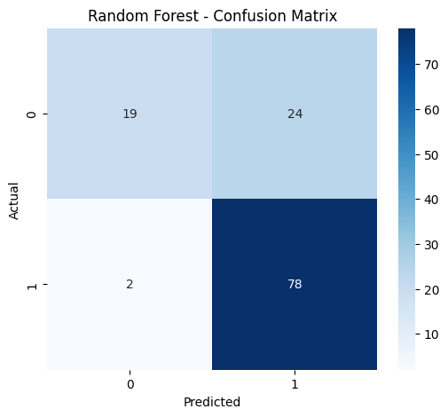
Figure 5: Confusion Matrix — Random Forest
Confusion Matrix values: True Negatives = 19, False Positives = 24, False Negatives = 2, True Positives = 78.
Interpretation: Random Forest matches Logistic Regression on overall accuracy and achieves slightly better precision, meaning marginally fewer applicants who should be rejected are approved by mistake, while still catching the vast majority of genuine approvals.

Feature Importance (Random Forest)
The Random Forest model's built-in feature importance highlights which inputs most influenced its predictions:
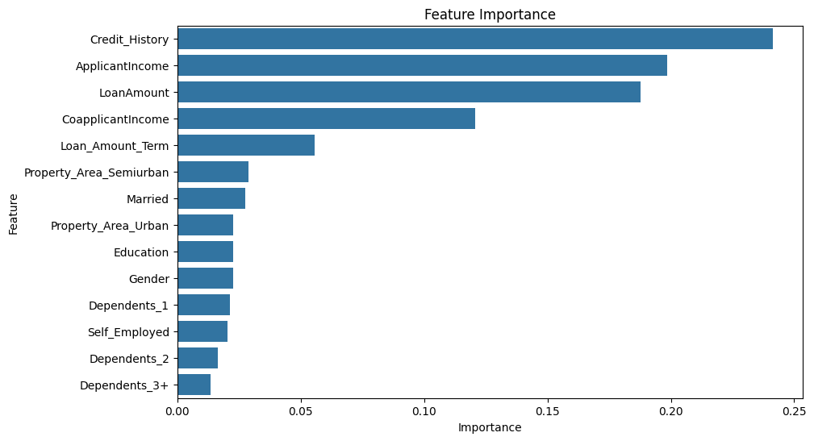
Figure 6: Random Forest Feature Importance
Rank | Feature | Importance
1 | Credit_History | 0.2413
2 | ApplicantIncome | 0.1986
3 | LoanAmount | 0.1877
4 | CoapplicantIncome | 0.1207
5 | Loan_Amount_Term | 0.0555
6 | Property_Area_Semiurban | 0.0289
7 | Married | 0.0276
8 | Property_Area_Urban | 0.0228
9 | Education | 0.0227
10 | Gender | 0.0226

Business Insight: Credit_History is, by a clear margin, the most decisive factor in the approval decision, followed by the applicant's own income and the requested loan amount. Demographic attributes such as Gender and Education rank lowest in importance, reinforcing the pattern already observed in the EDA — the bank's historical approvals appear to be driven primarily by financial and credit factors rather than demographic profile.

14.3 Decision Tree — Results
Metric | Score
Accuracy | 0.7561 (75.61%)
Precision | 0.7500
Recall | 0.9375
F1-Score | 0.8333

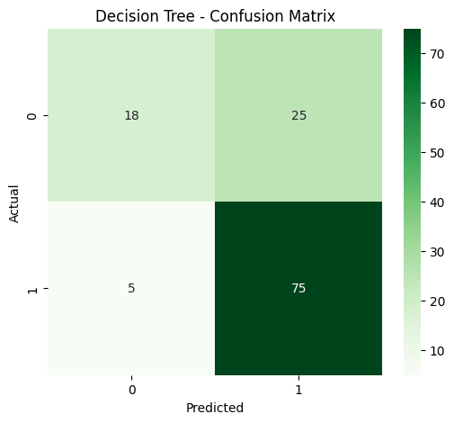
Figure 7: Confusion Matrix — Decision Tree
Interpretation: The single Decision Tree (max depth = 5) performs the weakest of the three models across every metric, though it is still reasonably competitive, showing that even a simple interpretable tree captures much of the underlying pattern in the data.

15. Model Comparison and Best Model Selection
All three models were consolidated into a single comparison table, sorted by accuracy:
Model | Accuracy | Precision | Recall | F1-Score
Logistic Regression | 0.7886 | 0.7596 | 0.9875 | 0.8587
Random Forest | 0.7886 | 0.7647 | 0.9750 | 0.8571
Decision Tree | 0.7561 | 0.7500 | 0.9375 | 0.8333

Best Model: Logistic Regression and Random Forest are statistically tied on accuracy (78.86%), and also very close on F1-Score. Logistic Regression edges ahead on Recall (98.75% vs 97.50%), meaning it misses slightly fewer genuinely eligible applicants, while Random Forest edges ahead on Precision. Given this near-tie, and consistent with the notebook's own model-saving step, Logistic Regression was selected as the final model for its strong recall, simplicity, and interpretability, which are valuable properties in a lending context where explaining a decision matters.

16. Model Saving and Loading using Joblib
The final Logistic Regression model was serialized to disk using joblib, so it can be reused later without retraining:
import joblib
joblib.dump(lr_model, "logistic_regression.pkl")
This produced the file logistic_regression.pkl. The notebook's current version saves the model but does not include a corresponding joblib.load() step to reload and reuse it.
Suggestion (not implemented in the current notebook): a companion loading step, such as loaded_model = joblib.load("logistic_regression.pkl"), together with saving the fitted StandardScaler object, would make the model directly reusable for predicting on new, unseen applications.

17. Results
Summarizing the outcome of this capstone project:
- The dataset of 614 loan applications was fully cleaned, with all missing values imputed and zero duplicates found.
- Three classification models were trained and compared on an 80/20 train-test split.
- Logistic Regression and Random Forest both achieved the top test accuracy of 78.86%.
- Logistic Regression achieved the highest Recall (98.75%) among all three models.
- Credit_History, ApplicantIncome, and LoanAmount were identified as the most influential predictors of loan approval.
- The final Logistic Regression model was saved as logistic_regression.pkl using Joblib.

18. Challenges Faced
- Missing data across multiple columns: Up to 50 missing values in Credit_History and smaller gaps in five other columns required careful, column-appropriate imputation (median for skewed numeric data, mode for categorical/discrete data) rather than a single blanket strategy.
- Mixed data types: The dataset combined binary categorical columns, multi-class categorical columns, and skewed numerical columns, requiring two different encoding strategies (Label Encoding and One-Hot Encoding) to be applied correctly.
- Class imbalance: With approvals outnumbering rejections roughly 2 to 1, accuracy alone could be a misleading measure of performance, making Precision, Recall, and F1-Score essential complements to accuracy.
- Small dataset size: With only 614 records (491 for training), model performance is more sensitive to the specific train-test split chosen, which is why a fixed random_state was used for reproducibility.

19. Business Impact
If integrated into a bank's loan processing workflow, this type of model could:
- Provide loan officers with an instant, data-driven second opinion alongside their own assessment of an application.
- Help prioritize manual review effort toward borderline or high-risk applications, rather than every application receiving equal scrutiny.
- Surface the key drivers behind a decision (e.g., via Random Forest feature importance) to support more transparent and explainable communication with applicants.
- Serve as a foundation that can be refined over time as more historical data and outcomes become available.
Given the model's current recall/precision trade-off, it would be best used as a decision-support tool that assists human underwriters, rather than as a fully automated, unsupervised approval system at this stage of development.

20. Future Scope
The following are suggested directions for extending this project; none of these are implemented in the current notebook:
- Train and evaluate the already-imported XGBoost classifier (XGBClassifier) alongside the existing three models.
- Apply hyperparameter tuning (e.g., GridSearchCV or RandomizedSearchCV) to improve upon the default model settings used here.
- Use k-fold cross-validation for a more robust estimate of model performance than a single train-test split.
- Address class imbalance explicitly using techniques such as class weighting or SMOTE-based oversampling.
- Engineer additional features, such as Total_Income (ApplicantIncome + CoapplicantIncome) or a Loan-to-Income ratio.
- Save the fitted StandardScaler alongside the model and add a joblib.load() based inference example for new applicants.
- Deploy the final model behind a simple API or web form so loan officers can obtain predictions interactively.

21. Conclusion
This capstone project successfully demonstrates an end-to-end machine learning pipeline for predicting bank loan approval, covering data cleaning, exploratory analysis, encoding, scaling, model training, and evaluation. Among the three models tested, Logistic Regression and Random Forest performed best, achieving 78.86% accuracy on the test set, with Logistic Regression showing a slight edge in recall and being selected as the final saved model. Credit_History was confirmed as the dominant factor behind loan approval decisions in this dataset, followed by income and loan amount. The project illustrates both the value and the current limitations of a straightforward baseline modelling approach, and lays a clear foundation for the future enhancements outlined above.

22. References
- Scikit-learn Documentation — https://scikit-learn.org/stable/documentation.html
- Pandas Documentation — https://pandas.pydata.org/docs/
- Seaborn Documentation — https://seaborn.pydata.org/
- Matplotlib Documentation — https://matplotlib.org/stable/contents.html
- Joblib Documentation — https://joblib.readthedocs.io/
- XGBoost Documentation — https://xgboost.readthedocs.io/ (referenced for future scope)
- Project source: week4.ipynb — Jupyter Notebook implementation prepared by Rupjit Das

